Project Report Template
Title of Project: Education and Digital Literacy
Name of the Innovator:Chiranjeevi.R
Start Date:13-09-2025
End Date: 17-09-2025

Day 1: Empathise & Defines
Step 1: Understanding the Need
- Which problem am I trying to solve?
Many students and individuals in underprivileged or rural areas lack access to quality education and digital literacy. This gap limits their opportunities for learning, career growth, and participation in the digital economy. With the increasing reliance on technology for education, work, and communication, the lack of digital skills and educational resources becomes a significant barrier to personal and professional development.
- Who is affected by this problem?
- How did I find out about this? [Select whichever is applicable]
- Interviews
- Observation
- Online Research
- AI Tools
Step 2: What is the problem?
The problem is that students in rural areas don’t have proper access to career guidance, skill training, and job opportunities. They often lack awareness about what courses to choose, available scholarships, and how to build employability skills, which limits their career growth.

Why is this problem important to solve?
• Equal Opportunity: Without access to education and digital literacy, many individuals cannot compete fairly in academics, jobs, or the digital economy.
• Empowerment: Education and digital skills empower people to improve their lives, make informed decisions, and access better career opportunities.
• Bridging the Digital Divide: As the world becomes increasingly digital, those without digital literacy are left behind, widening social and economic inequalities.
• Community & National Development: Educated and digitally skilled individuals contribute more effectively to society, innovation, and economic growth.

Ask 2-3 people what they think about the project:
Person 1 – Teacher / Educator:
"This project is very relevant because many students lack digital skills. Providing both education and digital literacy can significantly improve learning outcomes and prepare students for future opportunities."
Person 2 – Student / Youth:
"I think this project would help people like me learn technology and important subjects more easily. It could make studying more interesting and help us in exams and future jobs."
Person 3 – Community Member / Parent:
"Digital literacy is becoming essential for daily life. A project like this will help children and adults in our community access better education and opportunities that we couldn’t before."

AI Tools you can use for Step 1 and 2:
AI Tools Used:
1. Meta MGX
Used as a no-code development tool to design and deploy the CareerPath app.
It helps create interactive workflows, user interfaces, and logic without programming.
Ideal for building features like user registration
- 2. ChatGPT
- • Generates interactive tutorials, quizzes, study tips, and personalized learning recommendations to improve user engagement.
- • Can answer student questions in real-time, providing explanations and additional learning resources.
- • Supports multi-language assistance, helping students from different linguistic backgrounds.
- • Helps in career guidance and skill-building suggestions, aligning learning paths with future opportunities.
- • Improves user experience by simulating a human tutor for online learning.
- • Can assist teachers in creating lesson plans, assignments, and educational content efficiently.
- • Tracks common learning difficulties or frequently asked questions to improve curriculum design.
- • Encourages self-paced learning by guiding students without the need for constant supervision.

3. Chatbot References (Structure Design):
To design the AI virtual assistant, you can take reference from:
• Khan Academy’s Virtual Assistant
- Offers interactive guidance for learning modules and exercises.
- Provides hints, explanations, and step-by-step solutions.
• Duolingo Chatbot Design
- Simulates human-like conversations to teach languages.
- Uses gamification and instant feedback to engage learners.
• Microsoft Learn / AI Tutor
- Guides users through tutorials with contextual suggestions.
- Provides adaptive learning paths based on user progress.
• Coursera / EdX Discussion Assistants
- Helps answer common queries and provide resource recommendations.
- Supports multi-language interaction and course-specific guidance.
• Custom Workflow Design (Meta MGX Inspired)
- Structure the chatbot with user registration → course selection → skill module → quizzes → feedback → recommendations.
- Ensure interactive, responsive, and user-friendly conversation flows.

Day 2: Ideate
Step 3: Brainstorming solutions
- List at 5 differents soulations(wild or realistic)
• AI-Powered Virtual Learning Assistant
- A chatbot that guides learners through lessons, quizzes, and digital skill modules.
- Provides real-time answers to questions and personalized learning recommendations.
• Interactive Learning Modules
- Gamified courses for subjects like mathematics, science, and computer skills.
- Includes quizzes, tutorials, and progress tracking to engage students.
• Digital Literacy Workshops
- Online or offline sessions teaching basic computer skills, internet usage, and online safety.
- Helps adults and students develop practical digital skills for daily life and work.
• Personalized Learning Paths
- Using AI to track student progress and suggest topics based on strengths and weaknesses.
- Adaptive learning to ensure every learner progresses at their own pace.
• Offline Learning Support
- Downloadable content for students in areas with limited internet connectivity.
- Printed guides or community kiosks with digital resources.

Step 4: My favourite solution:
. My favourite solution for the Education and Digital Literacy Project is the AI-Powered Virtual Learning Assistant. This solution allows learners to receive personalized guidance based on their progress, strengths, and weaknesses. It makes learning interactive and engaging by providing real-time answers, quizzes, and tutorials, while also improving digital literacy skills. The platform is accessible anytime and anywhere, helping students in rural or underprivileged areas overcome barriers to education. Additionally, it supports teachers and parents in tracking progress and offering extra guidance when needed. This solution is scalable, efficient, and combines both education and digital literacy, making it the most effective choice to bridge the learning and technology gap for all learners.
Step 5: Why am I choosing this solution?
I am choosing the Education and Digital Literacy Platform because it combines AI-powered learning guidance, digital skill development, and personalized educational resources in one platform. It is easy to use, accessible anytime, and designed to empower students and community members, especially in rural areas, to gain knowledge, improve digital skills, and make informed learning and career decisions.

AI Tools you can use for Step 3-5:
AI Tools for Step 3–5
1. Meta MGX
- Used to design and build the CareerPath app without coding.
- Helps create the AI assistant, skill modules, and location-based features.
2. ChatGPT
- Helps brainstorm solutions and generate ideas for career guidance features.
- Can structure conversations for the AI virtual assistant.
- Assists in writing content for skill modules, FAQs, and recommendations.
3. AI Chatbot References (for design and flow)
- Dialogflow – Understands user intent and conversation flow.
- IBM Watson Assistant – Helps design structured Q&A for personalized guidance.
- Microsoft Bot Framework – Shows how to connect user inputs with recommendations and actions.
4. AI Research Tools
- Google Scholar / Research AI – For exploring existing solutions and innovative ideas for Steps 3–5.
- AI Text & Summarization Tools – Helps summarize solutions, select the best approach, and present them clearly.
AI Tools you can use for the take-home task:
Canva AI/CoPilot AI/Meta AI: Use these mobile-based tools to generate images for the solution they want to design
Day 3: Prototype & Test
Step 6: Prototype – Building my first version
What will my solution look like?
App / Platform Features:
- Home Screen: Welcomes the user and asks for basic info like age, education level, and location.
- AI-Powered Virtual Learning Assistant: Chat interface where users can ask about learning modules, digital skills, and study resources.
- Skill Development Section: Short modules for subjects like mathematics, science, digital literacy, and soft skills, with interactive exercises.
- Location-Based Learning Resources: Map or list showing nearby schools, libraries, community learning centers, and digital skill workshops.
- Profile Dashboard: Tracks the user’s progress, completed skill modules, and saved learning resources.
Design Style:
- Simple, intuitive, and easy to navigate for students and rural learners.
- Bright and engaging visuals to make learning and digital exploration fun.
- Mobile-friendly layout for easy access on smartphones and tablets.
Prototype Tools:
- Built using Meta MGX, no coding required, with all features interactive and testable for Education and Digital Literacy modules.
What AI tools will I need to build this?
AI Tools Needed to Build the Education and Digital Literacy Platform
- Meta MGX
  - No-code platform to design and deploy the learning platform.
  - Allows building interactive screens, chat interfaces, and skill modules for education and digital literacy without coding.
- ChatGPT (or similar LLMs)
  - To generate learning content, conversation flows, and educational guidance responses.
  - Can help personalize learning recommendations based on the user’s profile, progress, and location.
- AI Chatbot Design References
  - Google Dialogflow / IBM Watson Assistant / Microsoft Bot Framework
  - To structure conversation logic and handle student queries effectively.
- AI Recommendation Tools (Optional but useful)
  - For matching learners with relevant courses, skill modules, tutorials, and nearby learning resources.
  - Could use ML-based ranking algorithms or existing AI APIs for personalized learning paths.
- AI Data Analysis Tools (Optional for insights)
  - Python AI libraries (Pandas, Scikit-learn) or AI analytics platforms
  - To analyze user interactions, track learning progress, and improve content and recommendations over time.

What AI tools I finally selected to build this solution?
- Chat GPT
- Metamgx

< Build The Innovation>
<DASHBOAD OF THE TOOL>
Tool Link: https://mgx.dev/app/52a7152a501242b7ac5244651e44600e
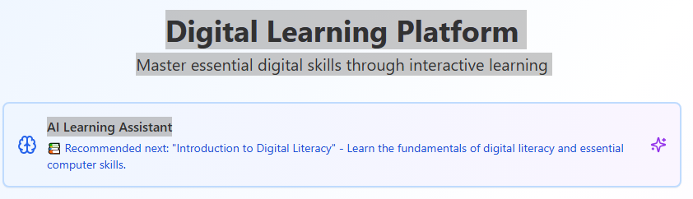

Internal Working of tool:
Profile Creation:
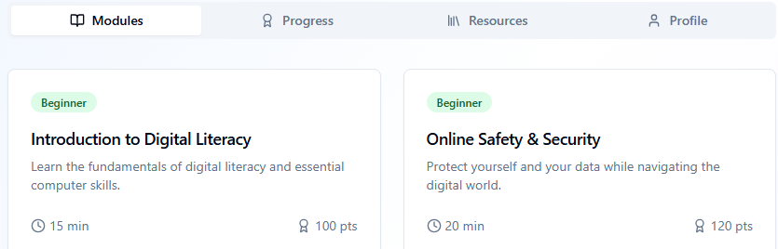

Tailoring recommendations using virtual assistant:
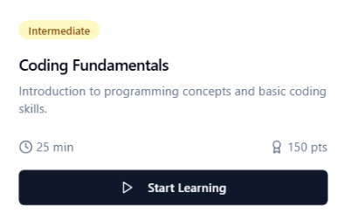
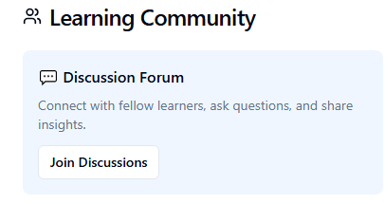

Job Recommendations based on Registered Profile:
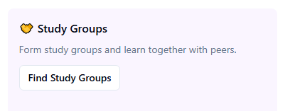

Collage Recommendations based on Profile:
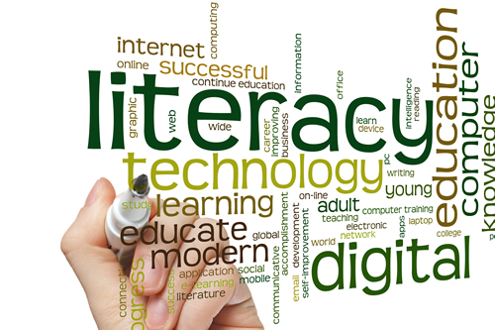
Step 7: Test – Getting Feedback
Who did I share my solution with?
I shared my CareerPath solution with:
• Classmates / Peers:
- To gather feedback on usability, navigation, and overall understanding of the digital literacy and career guidance features.
• Teachers / Mentors:
- To get expert advice on educational content accuracy, system design, and effectiveness in improving digital literacy.
• Friends / Potential Users:
- To understand user engagement, accessibility, and how helpful the solution is in guiding career and learning paths.

What feedback did I receive?
Feedback: Pros and Cons
Pros (Positive Insights from Feedback):
• Users found the CareerPath solution easy to navigate and user-friendly.
• The platform effectively enhances digital literacy skills through structured lessons and exercises.
• Interactive elements such as quizzes, progress tracking, and learning suggestions were appreciated.
• Teachers and mentors highlighted that the system supports self-paced learning and helps users plan their career paths.
• The feedback indicated that the solution is practical, engaging, and helpful for students and learners seeking guidance.

Cons (Areas to Improve Noted in Feedback):
• Some users suggested adding more multimedia content (videos, infographics) to make learning more engaging.
• Career guidance recommendations could be more personalized based on individual skills, interests, and learning progress.
• A few users requested offline access or downloadable resources for learners with limited internet connectivity.
• Features like progress tracking and dashboards could be made more detailed and visually intuitive.
• Some learners indicated the need for additional practice exercises and interactive challenges to reinforce digital literacy concepts.

My Response for The Feedback:
After receiving feedback from users, peers, and mentors, I focused on improving the CareerPath solution by making learning more engaging and accessible. I added multimedia content such as videos and infographics, enhanced career guidance recommendations to be more personalized based on individual skills and interests, and included downloadable resources for offline use. Additionally, I upgraded progress tracking and dashboards to be more intuitive and visually appealing, and added extra quizzes and interactive exercises to reinforce digital literacy concepts. These improvements ensure the platform is user-friendly, engaging, and effective in supporting learners’ education and career development.
👍 What works well:
What Works Well
- The CareerPath solution, built on Meta MGX, offers lifetime access without subscription fees, allowing updates and modifications anytime. Its no-code development approach makes it accessible to students and beginners without programming knowledge. The AI assistant provides personalized guidance on careers, scholarships, and job opportunities, accessibility, even in rural areas.

🔧 What needs improvement:
• Chatbot Responses: Currently, the AI sometimes repeats options, which can confuse learners.
• Interactive Features: Some learning modules and digital literacy exercises are restricted or not fully accessible in the prototype.
• Resource Integration: Limited access to educational content, digital literacy tutorials, and career-building resources.
• Collaborations Needed: To expand functionality, partnerships with educational institutions, NGOs, and other platforms are required.

AI Tools you can use for Step 6-7:
ChatGPT/Perplexity AI/Claude AI/Canva AI/Chatling AI/Figma AI/Metamgx/Gamma AI: You can use these tools to build solutions/models or mock-up dummy prototypes

Day 4: Showcase
Step 8: Presenting my Innovation:
I am presenting CareerPath, a digital education and digital literacy platform for rural youth. It features:
- An AI-powered virtual assistant that provides personalized guidance on learning pathways, digital skills, and educational opportunities.
- Skill development modules for digital literacy, English, aptitude, and soft skills.
- Location-based suggestions for nearby schools, training centers, and digital literacy programs.
- A user-friendly, mobile-friendly interface built on Meta MGX with lifetime access and easy updates.
Impact: CareerPath helps students improve digital literacy, make informed educational decisions, enhance employability, and bridge the education and guidance gap in rural areas.

<SHOWCASE YOUR INNOVATION TO YOUR PEERS>
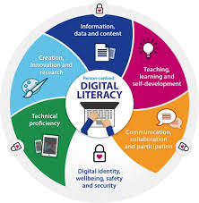

Step 9: Reflections
What did I enjoy the most during this project-based learning activity?
I enjoyed building CareerPath using a no-code tool and seeing my idea take a real, interactive form. It was exciting to design the AI assistant, digital literacy and skill development modules, and location-based features, and imagine how it could empower rural youth to improve their education, digital skills, and make informed learning decisions.

What was my biggest challenge during this project-based learning activity?
My biggest challenge was integrating all features smoothly in the prototype using a no-code tool, especially ensuring the AI assistant, skill modules, and location-based recommendations worked together effectively with limited resources.
Take-home task
https://github.com/punithhcreator/Careerpath-No-code-application
AI Tools you can use for Step 8:
Canva AI: You can use this to design your pitch document. Download your pitch document as a PDF file and upload on GitHub

